create database if not exists week_6;
use week_6;

-- query 1. Using Scheme diagram, Create tables by properly specifying the
-- primary keys and the foreign keys.

create table employee(empno int primary key,ename varchar(30),mgr_no int,hiredate date,sal int,deptno int);

alter table employee
add constraint fk_employeeupdated
foreign key (deptno) references dept(deptno)
on delete cascade;

create table dept(deptno int primary key,dname varchar(30),dloc varchar(30));

create table incentives(empno int,incentive_date date,incentive_amount int,primary key(empno,incentive_date),foreign key(empno) references employee(empno),on delete cascade);

create table project(pno int primary key,ploc varchar(30),pname varchar(30));

create table assigned_to(empno int,pno int,job_role varchar(30),primary key(empno,pno),foreign key(empno) references employee(empno) on delete cascade on update cascade,
foreign key(pno) references project(pno) on delete cascade on update cascade);assigned_toassigned_to
-- query 1 end

-- query 2. Enter greater than five tuples for each table.
INSERT INTO dept VALUES (10,'ACCOUNTING','MUMBAI');
INSERT INTO dept VALUES (20,'RESEARCH','BENGALURU');
INSERT INTO dept VALUES (30,'SALES','DELHI');
INSERT INTO dept VALUES (40,'OPERATIONS','CHENNAI');

INSERT INTO employee VALUES (7369,'Adarsh',7902,'2012-12-17','80000.00','20');
INSERT INTO employee VALUES (7499,'Shruthi',7698,'2013-02-20','16000.00','30');
INSERT INTO employee VALUES (7521,'Anvitha',7698,'2015-02-22','12500.00','30');
INSERT INTO employee VALUES (7566,'Tanvir',7839,'2008-04-02','29750.00','20');
INSERT INTO employee VALUES (7654,'Ramesh',7698,'2014-09-28','12500.00','30');
INSERT INTO employee VALUES (7698,'Kumar',7839,'2015-05-01','28500.00','30');
INSERT INTO employee VALUES (7782,'CLARK',7839,'2017-06-09','24500.00','10');
INSERT INTO employee VALUES (7788,'SCOTT',7566,'2010-12-09','30000.00','20');
INSERT INTO employee VALUES ('7839','KING',NULL,'2009-11-17','500000.00','10');
INSERT INTO employee VALUES ('7876','ADAMS',7788,'2013-01-12','11000.00','20');
INSERT INTO employee VALUES ('7900','JAMES',7698,'2017-12-03','9500.00','30');
INSERT INTO employee VALUES ('7902','FORD','7566','2010-12-03','30000.00','20');

INSERT INTO incentives VALUES(7499,'2019-02-01',5000.00);
INSERT INTO incentives VALUES(7521,'2019-03-01',2500.00);
INSERT INTO incentives VALUES(7566,'2022-02-01',5070.00);
INSERT INTO incentives VALUES(7654,'2020-02-01',2000.00);
INSERT INTO incentives VALUES(7654,'2022-04-01',879.00);
INSERT INTO incentives VALUES(7521,'2019-02-01',8000.00);
INSERT INTO incentives VALUES(7698,'2019-03-01',500.00);
INSERT INTO incentives VALUES(7698,'2020-03-01',9000.00);
INSERT INTO incentives VALUES(7698,'2022-04-01',4500.00);

INSERT INTO project VALUES(101,'AI Project','BENGALURU');
INSERT INTO project VALUES(102,'IOT','HYDERABAD');
INSERT INTO project VALUES(103,'BLOCKCHAIN','BENGALURU');
INSERT INTO project VALUES(104,'DATA SCIENCE','MYSURU');
INSERT INTO project VALUES(105,'AUTONOMUS SYSTEMS','PUNE');

INSERT INTO assigned_to VALUES(7499,101,'Software Engineer');
INSERT INTO assigned_to VALUES(7521,101,'Software Architect');
INSERT INTO assigned_to VALUES(7566,101,'Project Manager');
INSERT INTO assigned_to VALUES(7654,102,'Sales');
INSERT INTO assigned_to VALUES(7521,102,'Software Engineer');
INSERT INTO assigned_to VALUES(7499,102,'Software Engineer');
INSERT INTO assigned_to VALUES(7654,103,'Cyber Security');
INSERT INTO assigned_to VALUES(7698,104,'Software Engineer');
INSERT INTO assigned_to VALUES(7900,105,'Software Engineer');
INSERT INTO assigned_to VALUES(7839,104,'General Manager');

Select * from dept;
select * from employee;
select * from incentives;
select * from project;
select * from assigned_to;
-- query 2 end

-- query 3:Retrieve the employee numbers of all employees who work on
-- project located in Bengaluru, Hyderabad, or Mysuru

select employee.empno,project.pname
from employee,project,assigned_to
where assigned_to.empno=employee.empno and assigned_to.pno=project.pno
and project.pname in ("BENGALURU","HYDERABAD","MYSURU");

-- query 4. Get Employee ID’s of those employees who didn’t receive incentives

select empno
from employee
where empno not in(
select i.empno
from incentives i
);

-- query 5. Write a SQL query to find the employees name, number, dept,
-- job_role, department location and project location who are working for
-- a project location same as his/her department location.

select
emp.ename,emp.empno,d.dname,a.job_role,d.dloc,p.pname
from employee emp
join dept d on emp.deptno=d.deptno
join assigned_to a on a.empno=emp.empno
join project p on p.pno=a.pno
where p.pname=d.dloc;

query 1: Using Scheme diagram, Create tables by properly specifying the
primary keys and the foreign keys.
query 2. Enter greater than five tuples for each table.
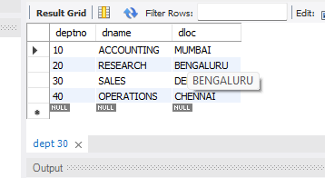
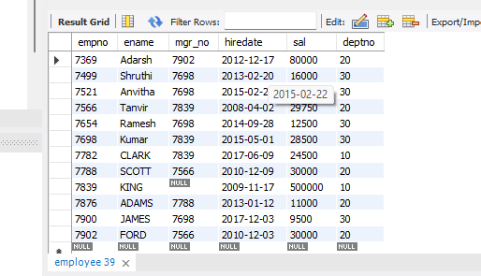

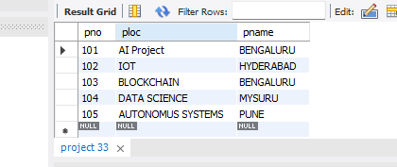
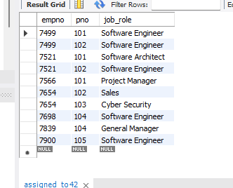

Query 3. Retrieve the employee numbers of all employees who work on
project located in Bengaluru, Hyderabad, or Mysuru

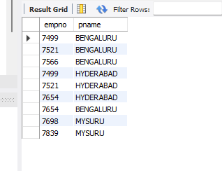

Query 4. Get Employee ID’s of those employees who didn’t receive incentives
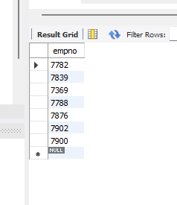
Query 5. Write a SQL query to find the employees name, number, dept,
job_role, department location and project location who are working for
a project location same as his/her department location.
